Nepal College of Information Technology
Assessment
Spring 2010
Program : BE IT Time : 3 hrs
Semester : Spring (II) FM : 100
Subject : Network Theory PM : 50

- Candidates are requested to give their answer as far as practicable in their own words.
- The figure in the margin indicates the full marks
- Attempt ALL question

1. a) In the network of the figure, the switch is in position 1 for long time. At t=0, the switch is moved from 1 to 2. Find V₂ (t) using the numerical values given in the network. Assume that the initial current in the 2H inductor in the figure is zero. [8]
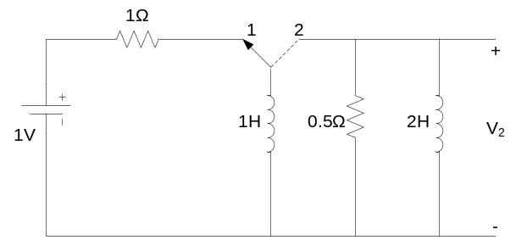
b) In the following network, switch K is changed from position a to position b at t=0. Solve for i, di/dt and d²i/dt² at t=0. [7]

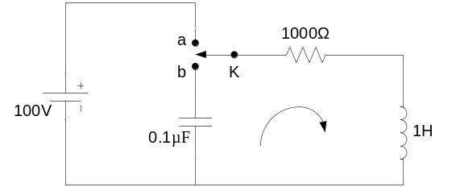

2. a) An exponential voltage V=4e^{-3t} is applied to a series RLC circuit consisting of resistor R=10Ω, inductor L=3H and capacitor C=0.05F at time t=0. The inductor and capacitor are initially uncharged. Obtain the general solution for current i(t) in circuit. Use time-domain method [8]
b) A sinusoidal voltage 15sin8t is applied at time t=0 to a series R-L circuit comprising of resistor R=4Ω and inductor L=1H. By the method of Laplace transformation, find current i(t). Assume zero current through inductor before application of voltage. [7]

3. a) Solve the following differential equation using the Laplace transformation method. [8]
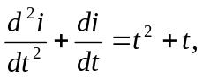 Given that 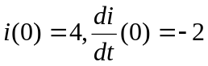
b) Apply the Routh Hurwitz criteria to the following equations and determine the number of roots with (a) positive real parts (b) negative real parts and (c) zero real parts. [7]
s⁵+2s⁴+2s³+4s²+11s+10=0
4. a) The waveform shown in the figure is trapezoidal in form and of period T=4a. For this periodic function, determine the Fourier coefficients. [8]
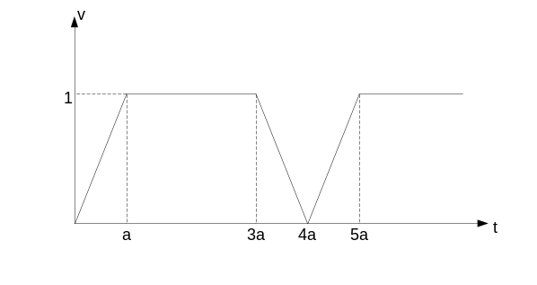
b) Find the time domain response of following transfer function using pole-zero plot. [7]
i(t) = 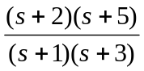
5. a) Plot the straight line asymptotic magnitude response for the network function: . 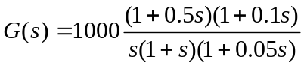 [8]
b) A function is given by 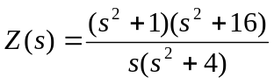. Realize it in the first and second form of Foster LC forms. [7]

6. a) Obtain the open circuit parameters for the network shown below. [8]
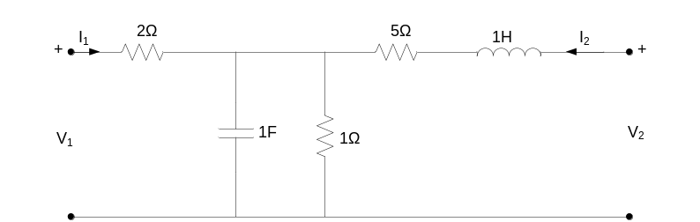
b) Find the h-parameter of the network drawn in figure below. [7]
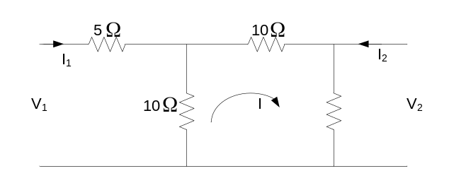
7. Write short notes on any two of the followings. [5*2=10]
a) Initial and Final Vale theorem
b) ilter and its types
c) Positive real function

